

**February Newsletter 2025**

**NOTES FROM THE OFFICE**

A huge **THANK YOU** to Emily Quigley for filling in for Emilie Tsirigotis during her leave. Emilie is gradually returning back to work over the coming weeks, increasing days each week. This month is registration month so spread the word to families in the community that registration is now completed online. Grade 4-5 students have been working on their Heritage Fair projects and families will be invited to see the students share their learning on February 25th.

**PARKING LOT SAFETY**

A reminder to parents that **the parking lot is closed to the community from 8am to 3pm.** This is to ensure safety for the students walking to and from school and to the bus each day. Please park cars along the side streets when dropping children off at school.

**IT IS COLD OUTSIDE**

Our goal is to get our students outside playing at lunch and recess as much as possible all year round. Daily exercise and fresh air helps students learn.. **Please ensure your children are dressed appropriately for the weather**. HRCE has provided us with some guidelines to assist us when we make a decision to send children outside. If the temperature is from 0C to -20Cwe consider several factors: the length of time outside, activity level, is the area windy or sunny. If the temperature is -21C to -27Cwe seriously consider whether it is appropriate to send students outside. If it is below -27C we do not send students outside. 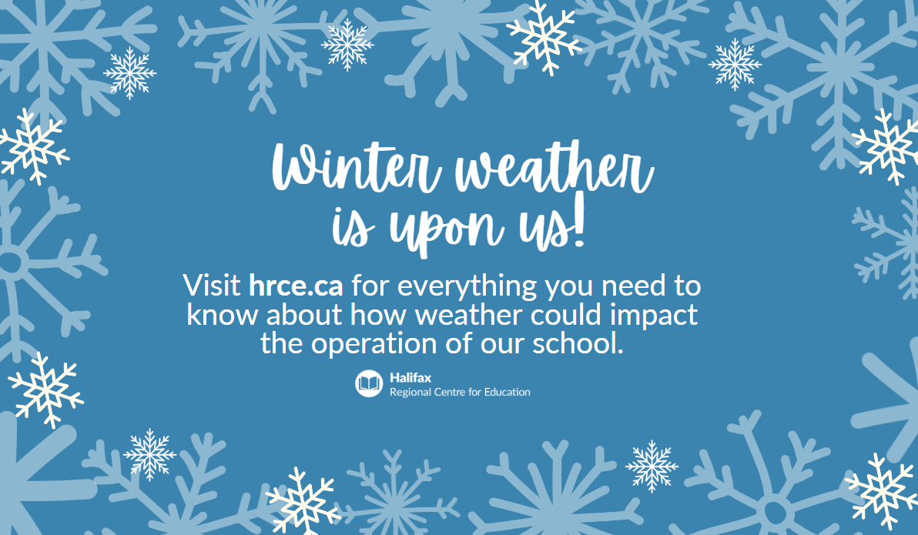

**SCHOOL SUCCESS PLAN**

All staff have been working with students on success and achievement through meaningful lessons and independent /small group sessions. In math, we continue to work on computational fluency, improving on students' ability to communicate learning and the use of mathematical strategies. In literacy, we continue to build phonological awareness while integrating these skills into the reading and writing process. Our Wellness goal will shift To developing rapport and trusting relations with all students using Culturally Responsive Teaching.

**CARING SCHOOLS**

**Empathy** is generally described as the ability to take on another person's perspective, to understand, feel, and possibly share and respond to their experience. Our monthly theme aligns with our SSP wellness goal. Teachers will support learners to further develop empathy during classroom circles and daily interactions/discussions.

**PTA / SAC**

The PTA sponsored dance that typically happens in January has been moved to Thursday March 6th. The following day is a PD day - no school for students. The SAC have worked with staff on the SSP wellness goal and plan to provide a drumming workshop to all students in April. Thank you again to the PTA/SAC for the successful apparel sales.

The **High Five Assembly** was on Thursday celebrating students who demonstrated a sense of belonging by including others during work and play.

The Girls for Greatness are selling **Candy Grams** this month: Please send the correct change for your order. Thank you! 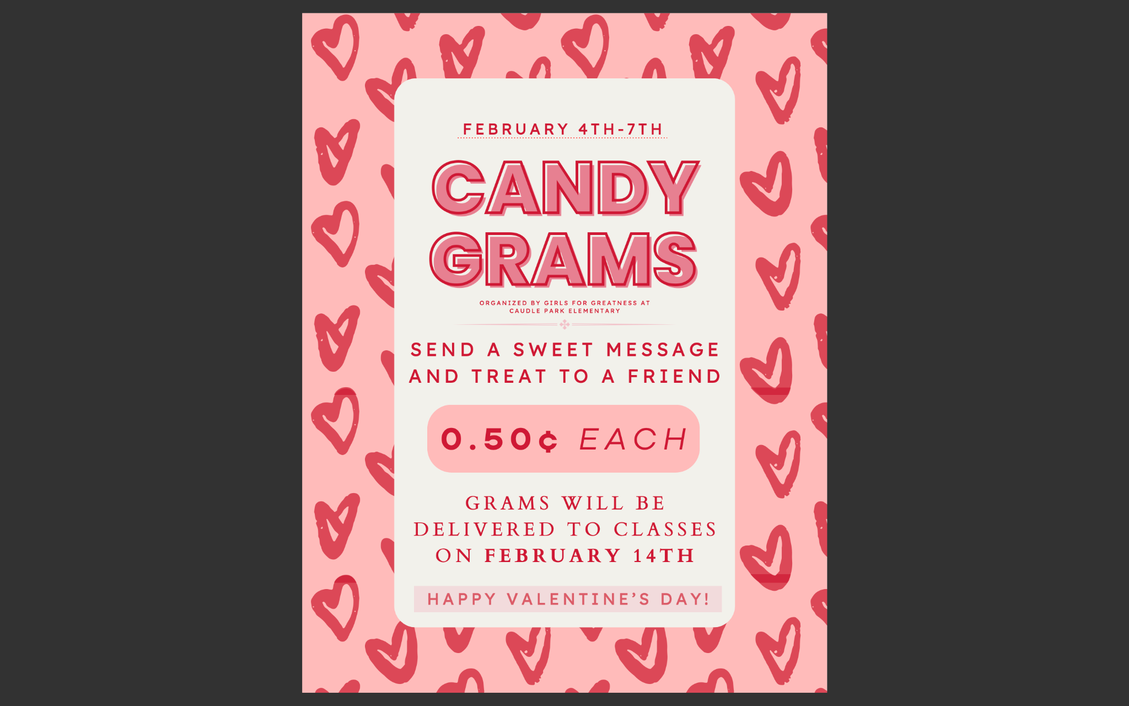

**FEBRUARY IS REGISTRATION MONTH**

Do you have a child who will be starting pre-primary or primary this fall? It’s time to register! **Registration for the 2025-26 school year begins on February 3.** To ensure we have the right staff and support in place for September, it’s important that we gather enrolment numbers now. **Tip:** Before you begin, make sure you have the following documents in electronic form (image, PDF or Word document):

* Proof of identity/age with one of the following: birth certificate, passport, immigration papers, or legal adoption papers) if you are new to the HRCE;
* Proof of home address (a recently dated official government or utility document with your current address that includes your name and date, such as water bill, power bill, internet bill, home fuel bill, a tax receipt, property assessment or a mortgage contract); and

Visit the [HRCE website](https://www.hrce.ca/families/student-registration-updates) for more information and to enrol your child today through PowerSchool Enrollment!

Don’t have a child to register? Maybe you know someone who does! Please help us spread the word and pass this information on to friends, neighbours or relatives who will be looking to register for the fall.

**UPCOMING DATES**

February 4-7th Candy Gram sales

February 14 Valentine's Day - Candy Gram delivery

February 25th - Heritage Fair