

**January 2025 Newsletter**

**Notes for the office**

Happy New year! Welcome back to all of our students and staff at Caudle Park Elementary. I hope that you had a wonderful, restful holiday season. We look forward to working with your children in 2025 and watching them learn and grow under the guidance of the amazing staff here at Caudle Park Elementary.

Emily Quigley

**It is cold outside**

Our goal is to get our students outside playing at lunch and recess as much as possible all year round. Daily exercise and fresh air helps students learn.. Please ensure your children are dressed appropriately for the weather. HRCE has provided us with some guidelines to assist us when we make a decision to send children outside. If the temperature is from 0C to -20Cwe consider several factors: the length of time outside, activity level, is the area windy or sunny. If the temperature is -21C to -27Cwe seriously consider whether it is appropriate to send students outside. If it is below -27C we do not send students outside. 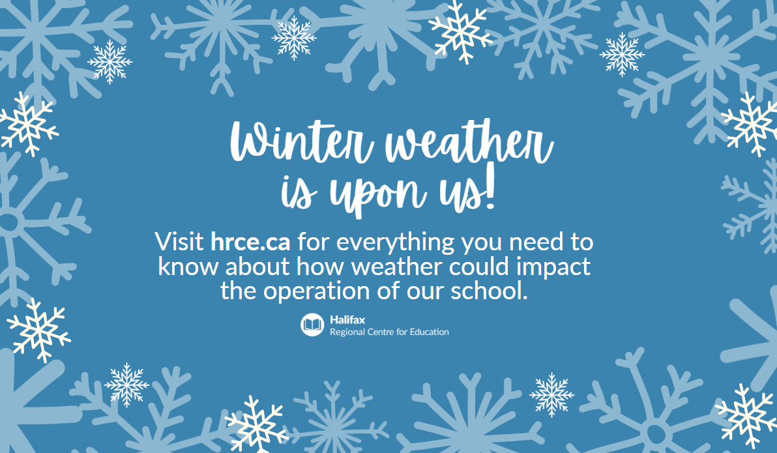

**Caring Schools**

Our theme this month is **belonging.** All students need to feel connected to others and have a sense of belonging. We wouldn’t want our students to feel alone and not part of a group when at school. We can strengthen a sense of belonging by the things we do and the connections we make with each other. It’s about the small moments each day, like saying hello, being genuine, listening and creating shared routines. This living value is connected to how students say and do small things, so things like passing unkind words off as ‘jokes’ negatively impacts on others' sense of belonging. As educators we take every opportunity to interrupt these interactions and teach students perspective and impact. These discussions can continue at home around hurtful jokes, quick judgements, online interactions and including/excluding others.

**High Five Awards**

As we communicated in October, this year at Caudle Park we want to recognize students who demonstrate the qualities of our monthly themes: **responsibility, gratitude, respect, cooperation, belonging, empathy, perseverance, kindness, acceptance and happiness.** At the end of each month we have a HIGH 5 Assembly. So far this year we have had **four HIGH FIVE Assemblies** and **85** students have been recognized for being responsible, respectful, demonstrating gratitude and cooperation. **HIGH FIVE Assemblies** are celebrations that are positive, fun, full of energy and excitement. Congratulations to all of our HIGH 5 winners so far this year.

**PTA / SAC**

Our amazing PTA continues to promote profitable and fun filled fundraisers. The Caudle Co Op was a huge success!. The event brought in over $750 All funds raised through this event went to the school Breakfast Program.. Thank you! The next event will be **February 12th with a family Winter Wonderland dance.** The SAC meets six times a year and continues to look at ways to support school improvement and student success.

**HRCE school cancellations**

HRCE takes great care when making the decision to alter the normal operations of schools and school buses. Would you like to be notified about school cancellations due to inclement weather by text message and/or email? [Subscribe to Notifications](https://www.hrce.ca/families/cancellations/subscribe-notifications)

**Water Bottles**

Please make sure you send in a full water bottle each day. We do not have water bottles or cups in the office.

**School Clothes**

A reminder that school clothes orders have arrived. Please come and pick up or call the school to have clothes given to your child.

**Lost and Found**

We have a number of items in our lost and found. If your child is missing any clothes please ask them to go to the lost and found and look for their clothes. We will be donating all Lost and Found items in mid January.

**Important Dates**

January 24 Family Literacy

February is Registration Month!

February 12 Winter Wonderland Dance

February 19 Day - No School

February 27 Heritage fair 1pm