



**March 2025 Newsletter**

**PRINCIPAL’S MESSAGE**

So happy to be back at school with the staff and students! I continue to work on a gradual return to work plan and am now in school 4 days per week. Eleanor Sperry, VP will continue to be in the office when I am not available. March weather can be unpredictable. Check [the weather](https://www.theweathernetwork.com/en/city/ca/nova-scotia/halifax/current) each morning and pack a change of clothes in your child’s backpack. The grounds can be wet at times and being proactive will decrease the calls home.

**Thursday March 5th is Spirit Day!**  Wear Blue or School Swag this thursday!. Go Caudle!!

**March Break is next week March 10-14. There is no school for students.**

Monday March 17th is St. Patrick’s Day, which historically has been a celebration of Irish culture and luck in Canada. Students are welcome to wear green to school.

**PARENT TEACHER ASSOCIATION (PTA)**

Thank you to everyone who ordered soup through the PTA. We will let you know when the order comes in.



The PTA is hosting a **Hawaiian Luau dance** on Thursday, March 6th, from 6:00 - 7:30 pm. The admission is $5/child or $10 for a family. There will be a cash canteen available with items ranging from $1 to $3. We are still looking for canteen volunteers. If you can help out click on this link: [Volunteers](https://docs.google.com/document/d/1ReneEX1o897G_aN5fkbC3fqa2ZrqZdtsMkXmiOsoJ3Q/edit?tab=t.0) .

Funds raised by the PTA pay for student school supplies each September, so your volunteer efforts are much appreciated!

**CARING SCHOOLS** 

Our Candy Grams were another HUGE success this year! Over 1,400 Candy Grams were sold and delivered to our students, with the most being 220 delivered in one classroom alone. Our students were beaming with gratitude and love! Funds earned will be going back into SchoolsPlus to purchase supplies and supports for our students to be more successful in their classrooms. Thank you to our families for supporting us! And thank you to our CPE leadership team, Girls for Greatness, SchoolsPlus staff Lindsey Morgan and Lisa MacDonald for all their hard work to organize this.

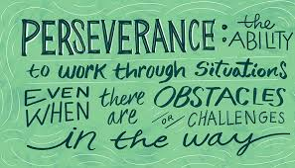

The theme for March is **Perseverance.** We encourage students to become independent learners through problem solving and sharing multiple strategies that will help with their learning.

**SCHOOL SUCCESS PLANNING**

We are in our second cycle of the school success plan and shifted our goals slightly in an effort to dig deeper into improved student learning.

**Literacy:** Transfer of phonics lessons during meaningful reading/writing experiences.

**Math:** Use the 3-part lesson format, placing an intentional focus on the "share" portion of the lesson to consolidate the intended learning target

**Wellbeing:** Develop rapport and trusting relations with all students using Culturally Responsive Teaching

We will have our first **Town Hall** this week with invited students to discuss school goals to get student feedback and suggestions.

**LUNCH HOUR**

This week classes will be provided with games bins for indoor recess and lunches. The bins are designed to promote positive play and relationships during an unstructured time.

Chess club has been running on Thursdays at lunch hour for students grades 3-5 and we have one week left. The students love this opportunity with retired teacher Mr. Balcom. Ms. Lindsay also runs lunch hour groups to strengthen student social emotional development.

**HERITAGE FAIR**



Students have been working on their projects over a number of months. This cross curricular project looks at non fiction learning and research, building reading and writing strategies, as well as learning about Canadian culture which is ever changing.

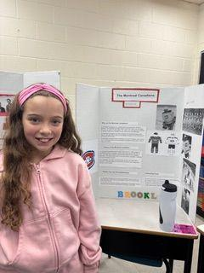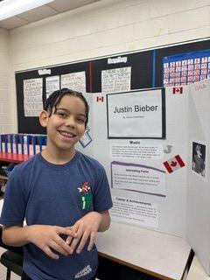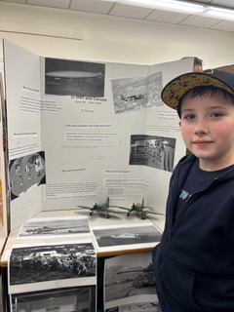

We share our learning…..

**DISCOVERY CENTRE**

Most classes will be participating in [Discovery Centre](https://thediscoverycentre.ca/) workshops to support the science curriculum at the end of the month. These workshops are hands-on and very engaging!

**UPCOMING DATES**

March 5 PTA setting up dance after school.

March 6 Spirit Day & PTA Family Dance

March 7 NO SCHOOL: Assessment and Evaluation Day

March 10-14 NO SCHOOL March Break

April 2 Report Cards emailed to families

April 3 Parent Teacher Interviews