SAC May 10
Agenda:
Principal Report
Math Infusion
Playground- Bikes/Scooters
Student Success Survey
Literacy Data

Minutes:
Members: Lacey, Gillian, Susan, Rebecca, Michelle, Scott, Emilie

Principal’s Report:
Registration 2022-2023 PP16 Pr 29
Congratulations to Pat, for getting the VP job at Tupper. Eleanor Skeary will be the new VP at Caudle next year. She is coming from Fairview Elementary. She is a ¾ teacher and I will likely keep her at that level.this will create a slight shift in some staff’s assignments for next year. I am really looking for leadership at the 4-5 level.
We received our staffing allocation this week and it looks the same as last year so not much in the way of changes. Our class configurations will remain much the same as well. Currently looking to fill: P/1 ¾ back fill .5 LC .1 relief

Extracurriculars: We have had positive extras over the past couple of months. Lunch time intramurals and chess have been excellent. Chess invited gr 3’s for a few sessions as well. Peter will return for 1 paper airplane event. Drumming was a huge success and we rebooked for next year. Hope for Wildlife was in today and will be returning for 2 more sessions.

Math infusions: We purchased the deck of cards for classes and some dominoes. We are still looking for more dominoes for classes but they have been challenging to find. The whiteboards were purchased and are being cut for $150ish. The hand writing hasn’t been purchased yet.

Bike rack and storage shed: We have been in touch with HRM about the bike racks and they don’t recall any removal of a bike rack. They don't typically install them. We have quotes from uline and amazon. Will contact Eastern Fence as recommended by HRM. We priced Plastic storage bins and when operations were last here they recommended metal ones. The cost would be about $2500.00 and it is non combustible. We would use it for PP and scooters. Operations does have a bike rack for us so we no longer need to direct funds there.

Student Success Survey. The 4-5 students have completed the survey for this year Important information on relationships in school, beliefs about school, school environment, time at school, food security

Literacy Data Primary is about the same. Students are progressing quite well. Grade 1 Slight improvement (3 students). Grade 2 slight decrease (3 students). Expect flux but we could look closely at the reading / writing behaviors at each level. Use of Fundations to build PA…(need to extend student knowledge of vowel teams, word patterns, extending sentence structure. We will be working with PLC groups to extend sounds and strategies.

Breakfast Program Expansion of the breakfast program has been a huge success. We found a retired neighbor who has agreed to make weekly muffins for us. They are delicious! We started to make egg sandwiches as well which has been popular too.

Hazard Inspection we completed the biannual hazard inspection. One item that should be highlighted is the internal water damage during heavy rains. Work orders have been placed for brick work to begin this spring summer. If this continues to be ongoing the OHS will bring it forward as a health concern. We are also looking at increased lighting and police patrol for increased evening activity on the grounds. We have work orders in with HRM to fix up the grounds (guard rail/playground repairs). HRCE is looking into the driveway. Fire drill will be next week.

Finances: $1020

Further Discussion:
Grounds: Emilie to look into further conversation with HRM about the field and surrounding woods area. A lot of downed trees and evidence of fire. Also, we discussed the poor drainage at the front hill. Water is currently running into the school and down the driveway which is deteriorating the asphalt. Emilie will discuss with our operations supervisor when he is here next.A work order is currently in with operations to repair the driveway. Another suggestion is to request more surveillance signs for the back/ sides of the building.

Metal shed: It was recommended that we look at Wayfair for a metal shed for scooters.
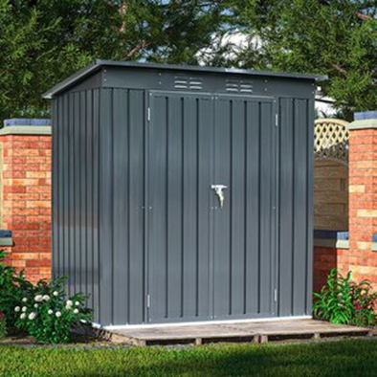
Cost: about $500
Here are the features:
· Unlike typical sheds with plastic vents, this shed comes with two integrated punched vents that will not deteriorate against sunlight.
· Nothing irks a garden hobbyist more than the sight of a collapsed shed. Luckily, this shed utilizes sui generis aluminum frames which greatly increase the overall sturdiness. On top of that, the galvanized steel panels, coated with eco-friendly painting, can endure harsh weather for at least 10 years.
· Double sliding door, increase both air circulating and light, preventing sweltering in summer and trembling in winter. A hinged door offers more customization opportunities than a sliding door does. A heavy-duty complimentary padlock grants extra safety.
· The roof can hold approximately 450 pounds
In consultation with operations, they felt this might be a good option. We could dismantle it and store it inside for the colder months and summer to prevent weather damage and vandalism. My biggest concern is that it doesn’t have a floor and might be easy to flip. It will be placed on asphalt in the front of the school. We could check if there was a way to secure it to the ground or building or have a wooden floor build that it can be attached to. Any suggestions? Further thoughts? Please email Emilie.

Thank you everyone for your ongoing support of our school and programming!

